Muhammad furqan
(Su92-bscsm-f24-020)

Program 1
(Multiplication table)
#include <iostream>
using namespace std;
int main()
{
for (int i = 1; i <= 5; i++)
{
for (int j = 1; j <= 5; j++)
{
cout << i * j << "\t";
}
cout << endl;
}
return 0;
}
Output 1
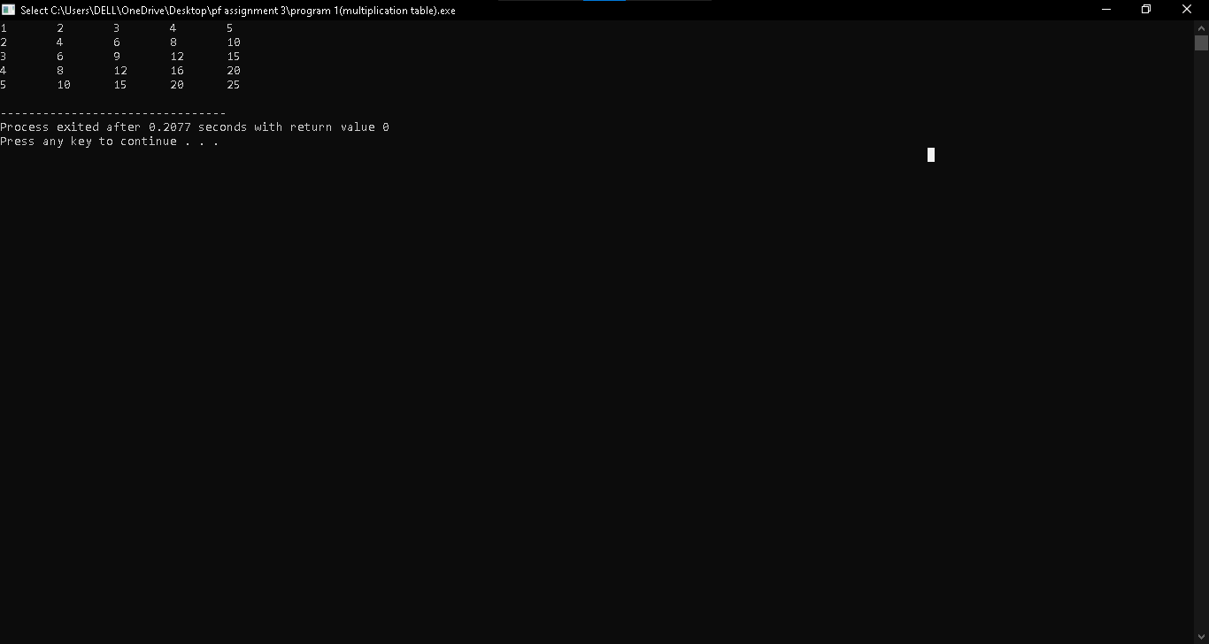
Program 2
(number triangle)
#include <iostream>
using namespace std;
int main()
{
for (int i = 1; i <= 5; i++)
{
for (int j = 1; j <= i; j++)
{
cout << j << " ";
}
cout << endl;
}
return 0;
}
Output 2
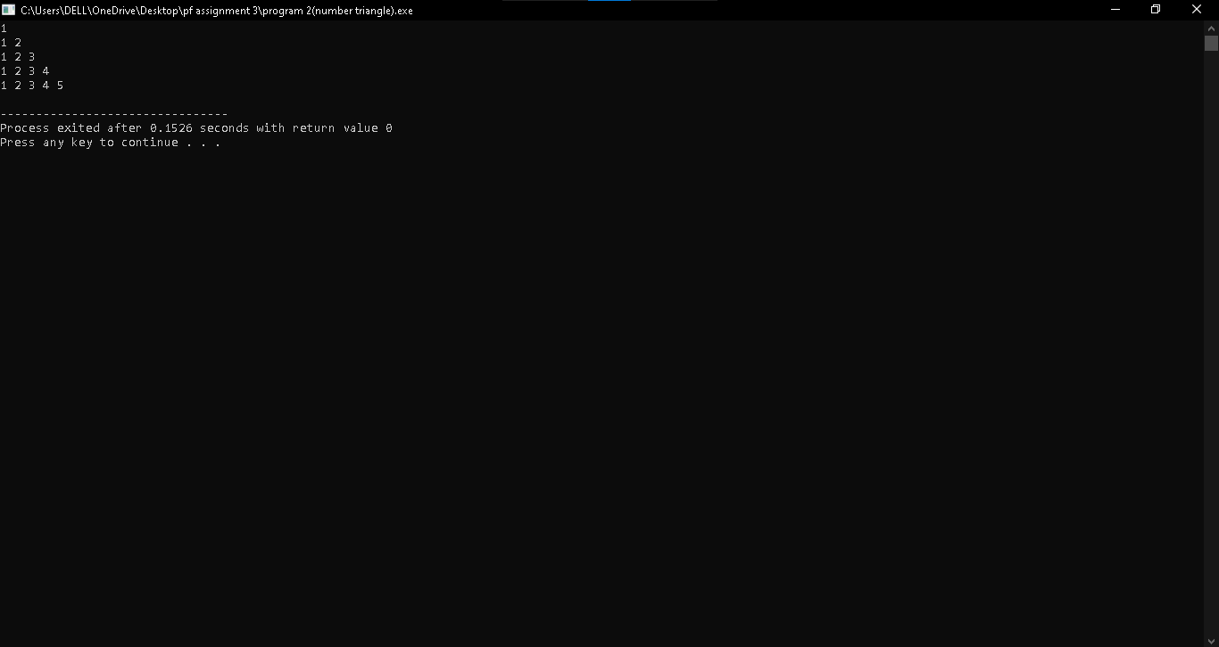
Program 3
(reverse triangle)
#include <iostream>
using namespace std;
int main()
{
for (int i = 5; i >= 1; i--)
{
for (int j = 1; j <= i; j++)
{
cout << j << " ";
}
cout << endl;
}
return 0;
}
Output 3 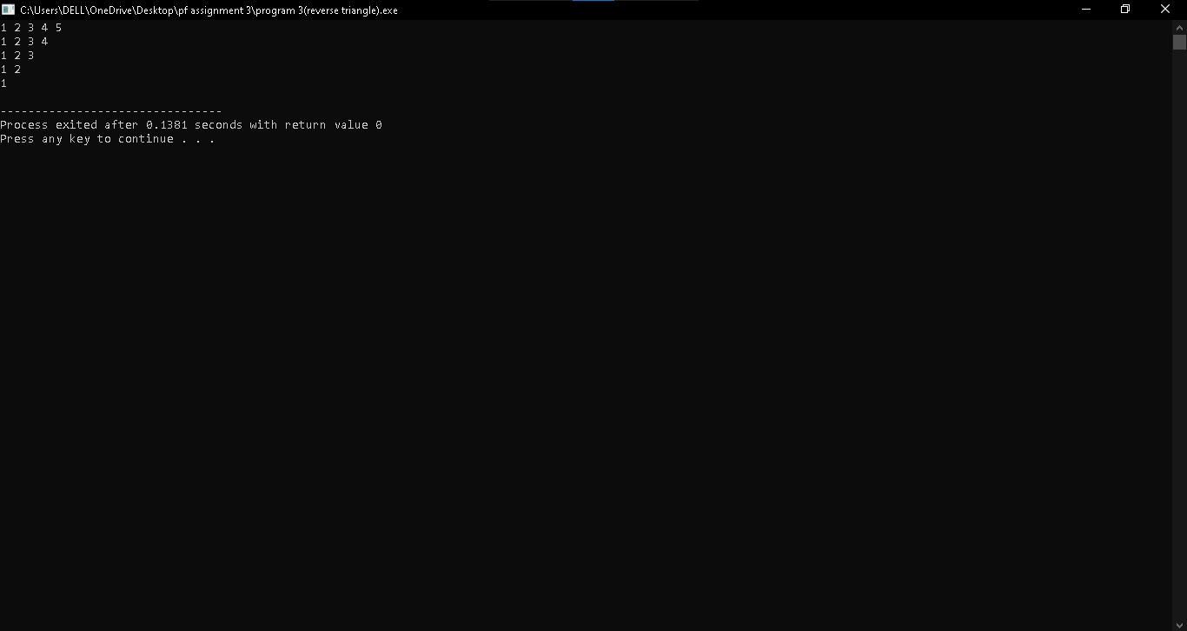
Program 4
(same mumber triangle)
#include <iostream>
using namespace std;
int main()
{
for (int i = 1; i <= 5; i++)
{
for (int j = 1; j <= i; j++)
{
cout << i << " ";
}
cout << endl;
}
return 0;
}
Output 4
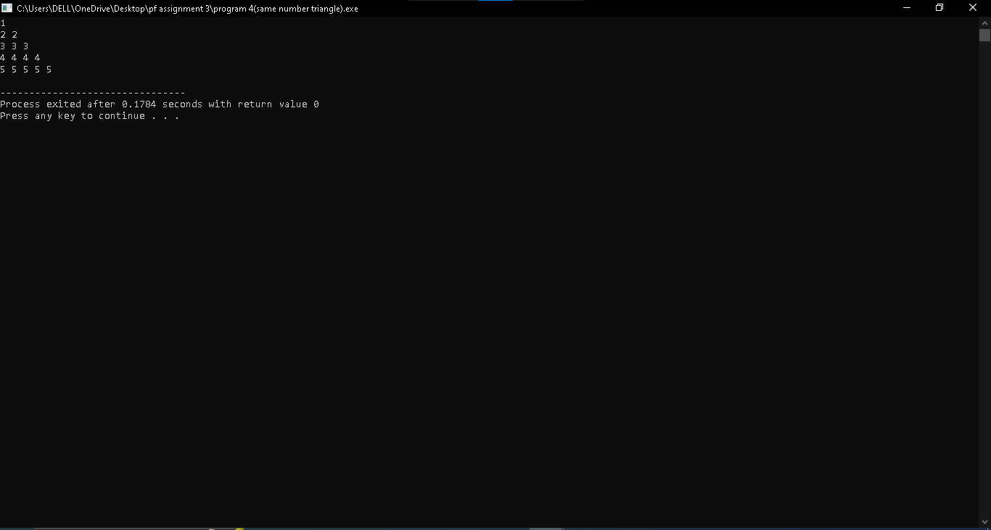
Program 5
(reverse count triangle)
#include <iostream>
using namespace std;
int main() {
for (int i = 1; i <= 5; i++)
{
for (int j = i; j >= 1; j--)
{
cout << j << " ";
}
cout << endl;
}
return 0;
}
Output 5
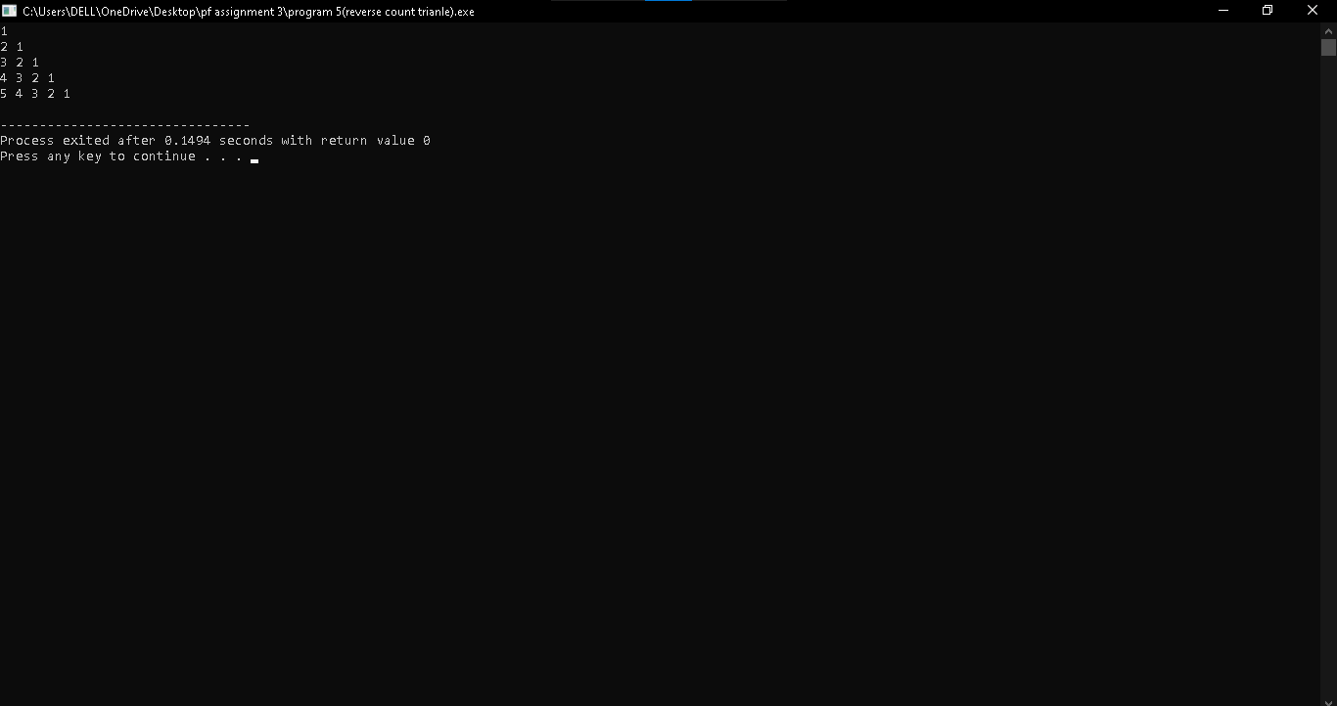
Program 6
(alphabet triangle)
#include <iostream>
using namespace std;

int main() {
char ch = 'A';
for (int i = 1; i <= 5; i++)
{
for (int j = 1; j <= i; j++)
{
cout << ch << " ";
}
ch++;
cout << endl;
}
return 0;
}
Output 6 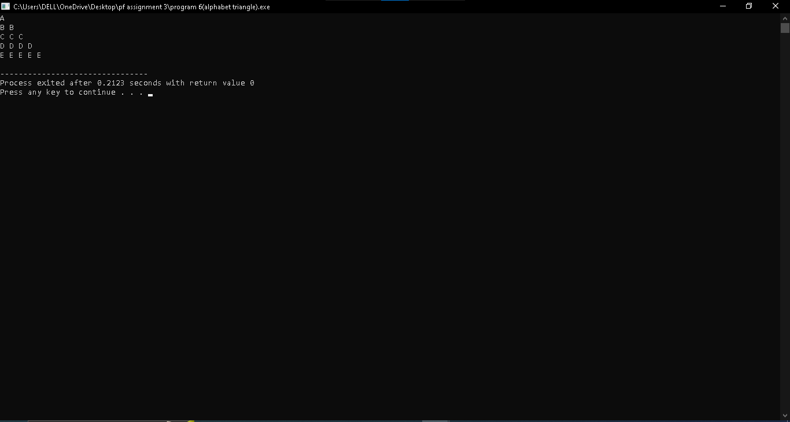
Program 7
(square pattern)
#include <iostream>
using namespace std;

int main()
{
for (int i = 1; i <= 5; i++)
{
for (int j = 1; j <= 5; j++)
{
cout << "* ";
}
cout << endl;
}
return 0;
}
Output 7
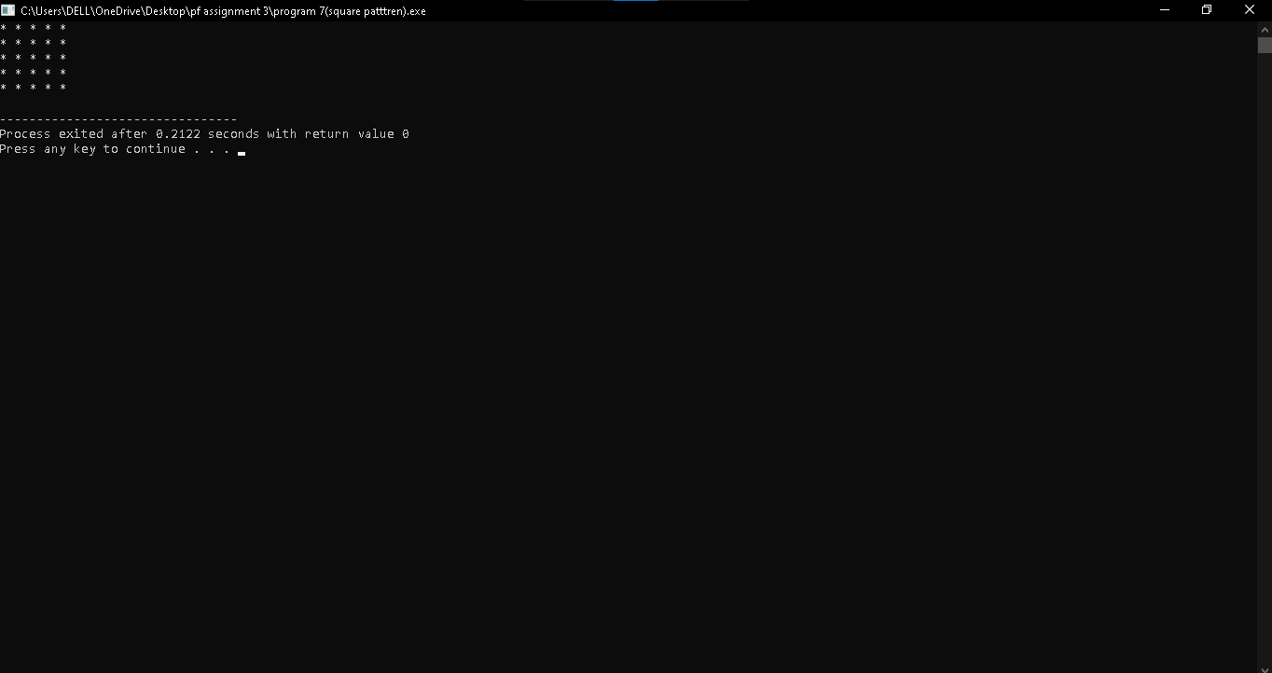
Program 8
(rightangle triangle)
#include <iostream>
using namespace std;
int main()
{
for (int i = 1; i <= 4; i++)
{
for (int j = 1; j <= i; j++)
{
cout << "* ";
}
cout << endl;
}
return 0;
}
Output 8 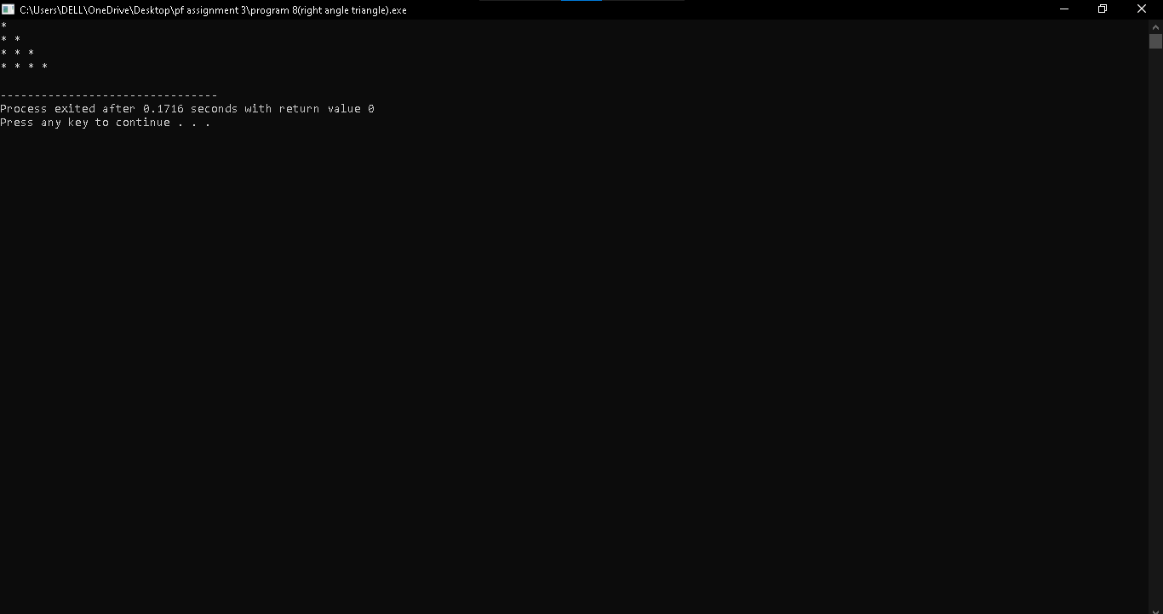
Program 9
(inverted rightangle triangle)
#include <iostream>
using namespace std;
int main()
{
for (int i = 4; i >= 1; i--)
{
for (int j = 1; j <= i; j++)
{
cout << "* ";
}
cout << endl;
}
return 0;
}
Output 9
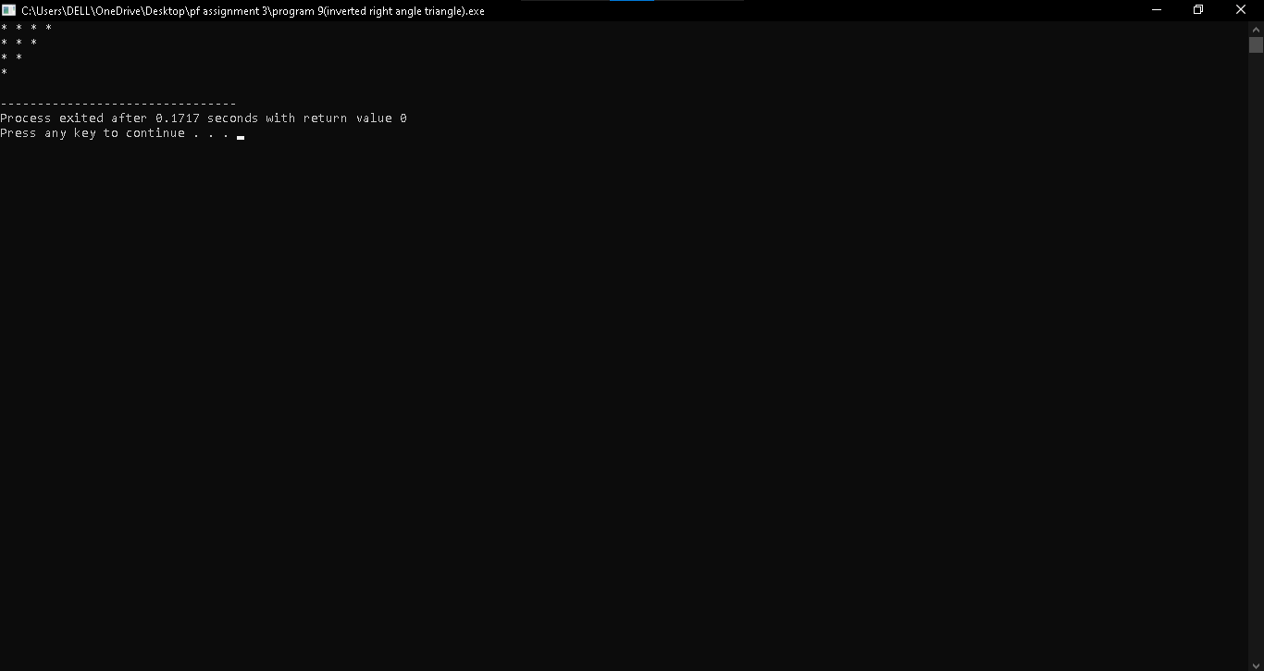
Program 10
(hollow square)
#include <iostream>
using namespace std;
int main()
{
for (int i = 1; i <= 5; i++)
{
for (int j = 1; j <= 5; j++)
{
if (i == 1 || i == 5 || j == 1 || j == 5)
cout << "* ";
else
cout << " ";
}
cout << endl;
}
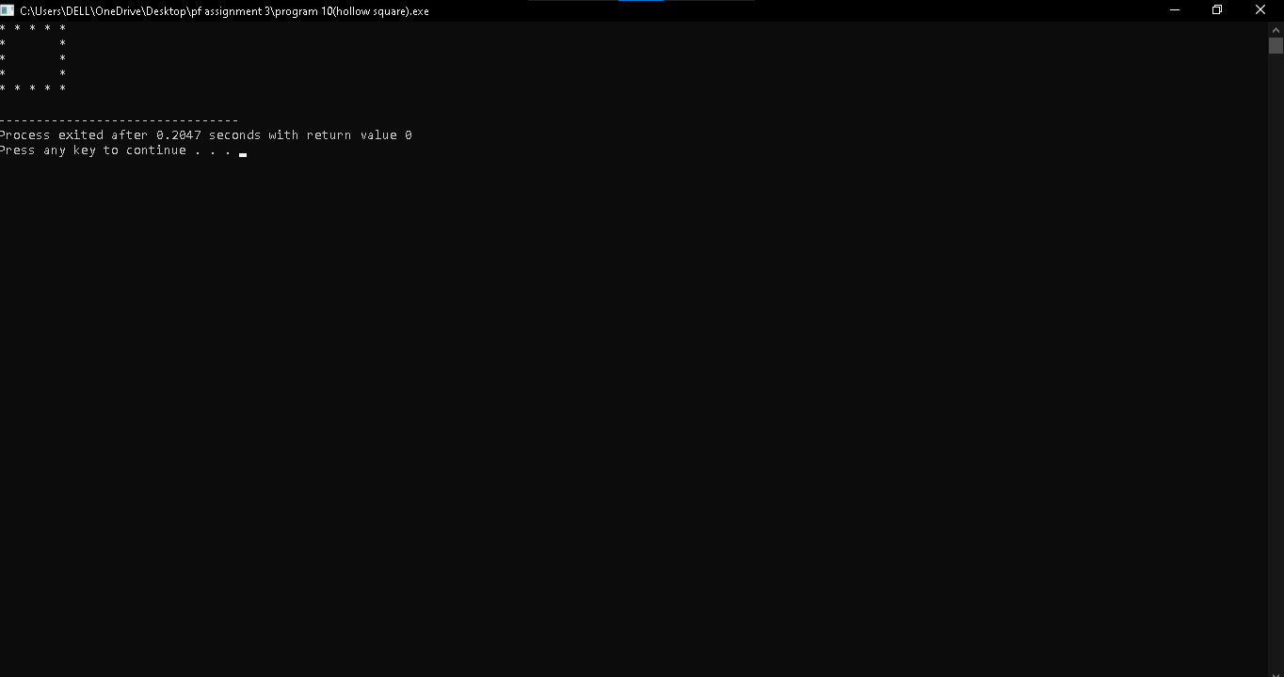
Program 11
(To print 11 two times)
#include <iostream>
using namespace std;

int main()
{
for (int i = 0; i < 2; i++)
{

for (int j = 0; j < 2; j++)
{
cout << "1";
}
cout << endl;
}
return 0;
}
Output 11
